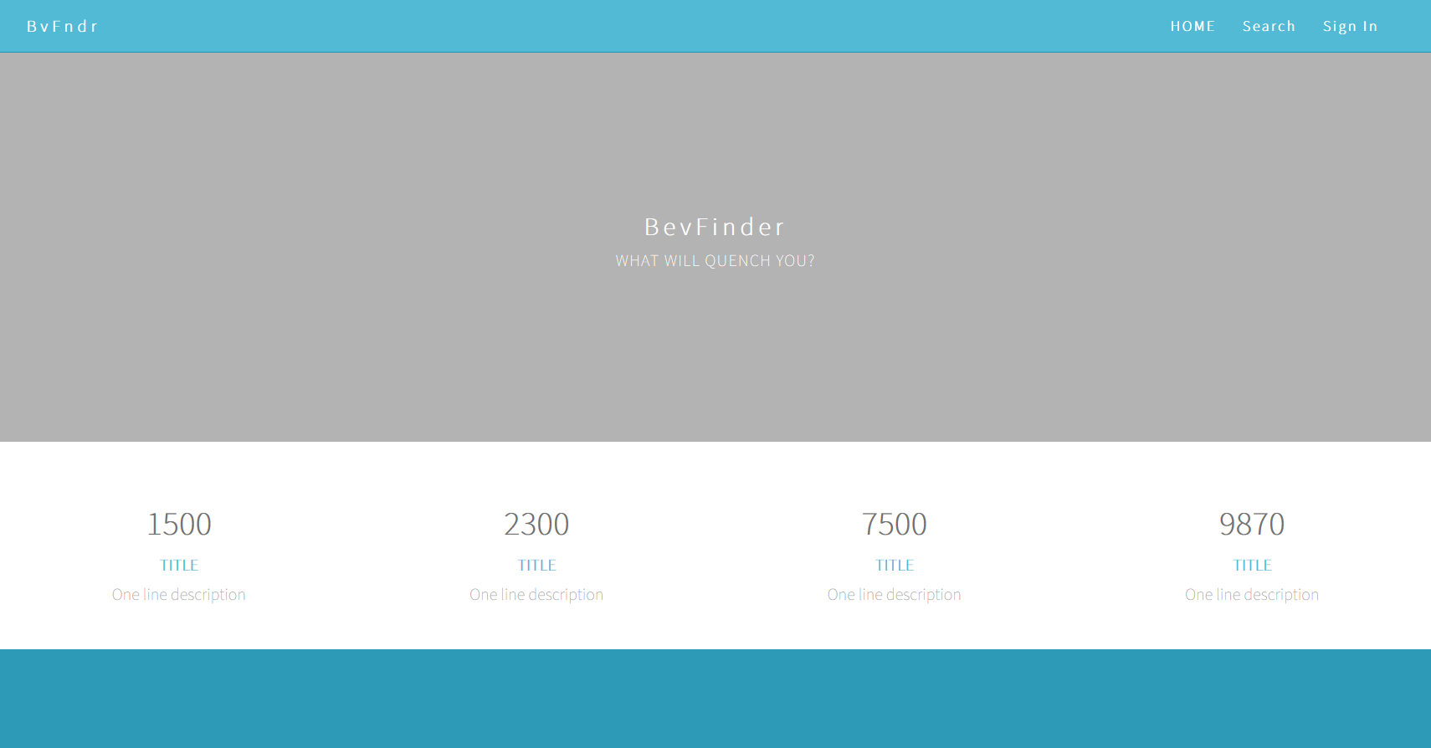

This is the main page, still working on a main logo. This displays the main functionality of a home INFO page, a search, and a sign in for members who can save their searches.

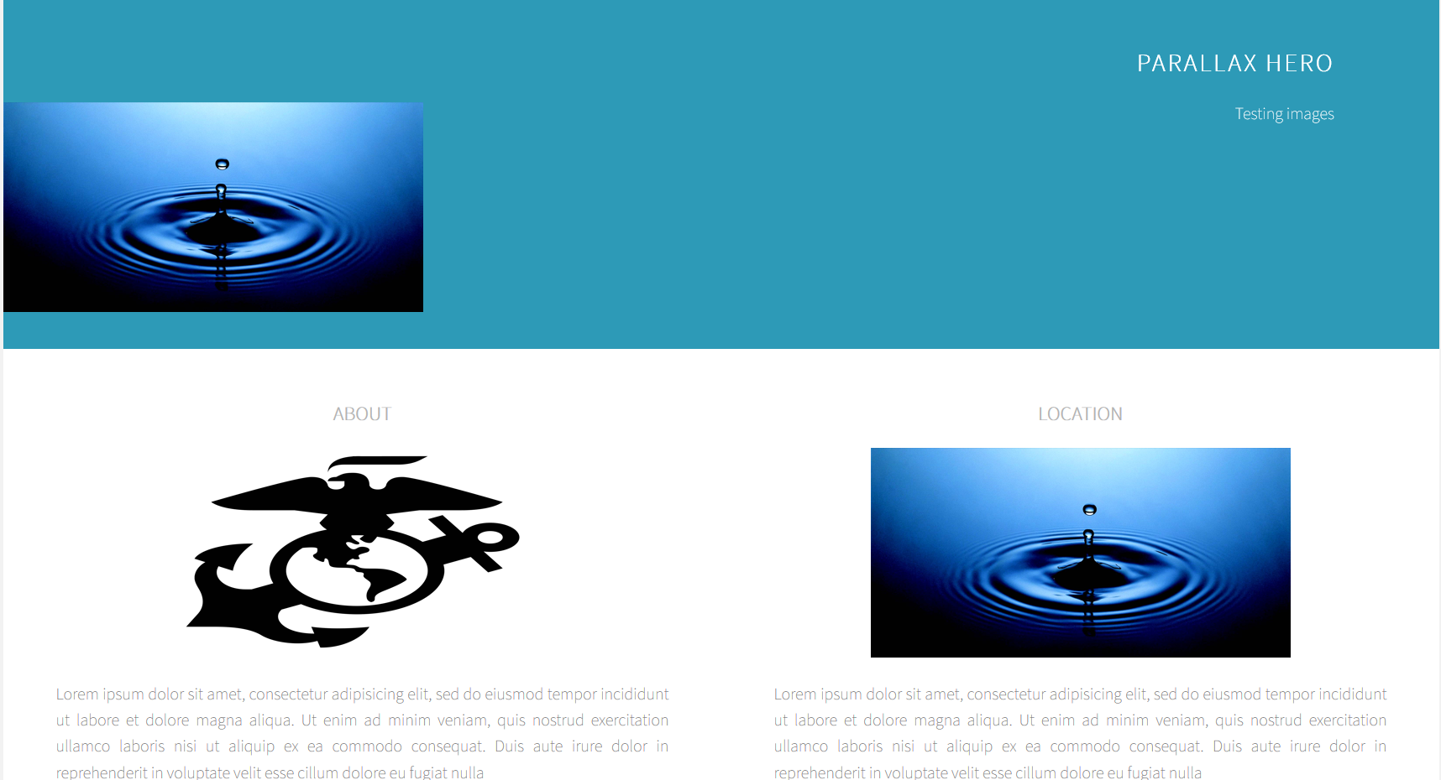

This half of the page is simply testing what I can do with the HTML

The next pages are under construction. The next page will mostly be a google maps API with an overlay